Practice Exercise – Easy

**Directions (Q. Nos. 1 – 3):** *Answer the questions based on the following information.*

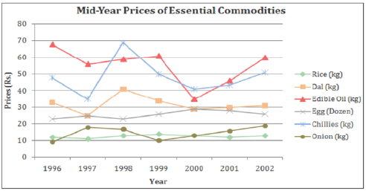

**[CAT 2003]**

1. During 1996-2002, the number of commodities that exhibited a net overall increase and net overall

decrease, respectively, were:

a. 3 and 3 b. 2 and 4 c. 4 and 2 d. 5 and 1

2. The number of commodities that experienced a price decline for two or more consecutive years is

a. 2 b. 3 c. 4 d. 5

3. For which commodities did a price increase immediately follow a price decline only once in this period?

a. Rice, edible oil and dal b. Egg and dal

c. Onion only d. Egg and onion

**Directions (Q. Nos. 4 – 7):** *Answer the questions based on the following information.*

The figure below represents sales and net profit in Rs. crore of IVP Ltd. for five years from 1994-95 to 1998-99. During this period the sales increased from Rs. 100 crore to Rs. 680 crore. Correspondingly, the net profit increased from Rs. 2.5 crore to Rs. 12 crore. Net profit is defined as the excess of sales over total costs.

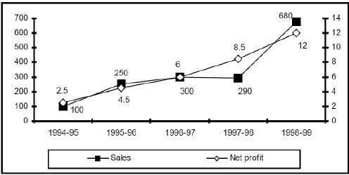

4. The highest percentage of growth in sales, relative to the previous year, occurred in:

a. 1995-96 b. 1996-97 c. 1997-98 d. 1998-99

5. The highest percentage growth in net profit, relative to the previous year, was achieved in:

a. 1998-99 b. 1997-98 c. 1996-97 d. 1995-96

6. Defining profitability as the ratio of net profit to sales, IVP Ltd., recorded the highest profitability in

a. 1998-99 b. 1997-98 c. 1994-95 d. 1996-97

7. With profitability as defined in question 6 above, it can be concluded that:

a. profitability is non-decreasing during the five years from 1994-95 to 1998-99.

b. profitability is non-increasing during the five years from 1994-95 to 1998-99.

c. profitability remained constant during the five years from 1994-95 to 1998-99.

d. None of the above

**Directions (Q. Nos. 8 – 11):** *Answer the questions based on the following information.*

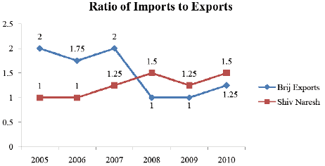

**Years**

8. In how many of the given years were the imports more than the exports for Brij Exports?

a. 2 b. 3 c. 4 d. 5

9. If the exports of Brij Exports in 2007 were increased by 40 %, what would be the ratio of imports to the increased exports?

a. 1.27 b. 1.36

c. 1.42 d. Cannot be determined

10. If the imports of Shiv Naresh in 2008 were 438 million, what was the amount of exports in that year?

a. 181 million b. 292 million

c. 343 million d. 402 million

11. In 2005, the import of Brij Exports was double that of Shiv Naresh in 2008. If the exports of Brij Exports during the year was 540 million, what was the approximate difference in imports & exports of Shiv Naresh during that year?

a. 180 million b. 210 million

c. 225 million d. Cannot be determined

**Directions (Q. Nos. 12 – 15):** *Answer the questions based on the following information.*

Following line graph shows the percentage increase in the birth rate of 4 African countries during the year Y1 to Y6 with respect to previous year.

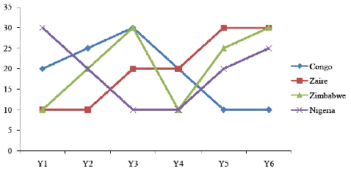

The change in birth rate of country is calculated on 1st January of each year.

12. If the ratio of birth rate of Congo and and Zaire at the end of the year Y2 was 5 : 7, then what was the ratio of their birth rate at the end of the year Y6?

a. 411 : 832 b. 605 : 1092

c. 750 : 1490 d. 835 : 1709

13. If the ratio of the birth rate of Congo, Zaire, Zimbabwe and Nigeria at the end of the year Y1 was 22 : 13 : 7 : 13, then what was the ratio of their birth rate at the end of the year Y4?

a. 20 : 12 : 7 : 11 b. 25 : 12 : 7 : 11

c. 25 : 12 : 7 : 13 d. 25 : 7 : 12 : 11

14. If the birth rate of Zaire and Zimbabwe were equal at the end of the year Y2, then what was the ratio of the birth rate of Zaire and Zimbabwe at the end of the year Y4?

a. 12 : 11 b. 144 : 143

c. 132 : 143 d. 66 : 77

15. If the birth rate of Congo at the end of the year Y2 was 156, then what was his birth rate at the end of the year Y6?

a. 281.36 b. 287.89

c. 294.46 d. 295.77

**Directions (Q. Nos. 16 – 18):** *Answer the questions based on the following information.*

The graph provides information about new cars purchased globally for luxury and mid segments cars (in millions) from 2010 to 2014.

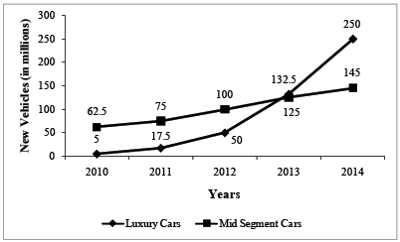

16. Which year showed the highest growth rate in new luxury cars compared to previous year?

a. 2012 b. 2011 c. 2013 d. 2014

17. Mid segment cars form what percentage of total cars at the end of 2014. (Assume no cars were sold before 2010 and only these 2 cars are sold)?

a. 53.5% b. 51.96% c. 55.21% d. 54.3%

18. In which year did new luxury cars form the highest percentage of total new cars?

a. 2010 b. 2011

c. 2013 d. None of these

Practice Exercise – Medium

**Directions (Q. Nos. 1 – 6):** *Answer the questions based on the following information.*

The graph given below shows the quantity of milk and food grains consumed annually along with female and male population (in millions). Use the data to answer the questions that follow.

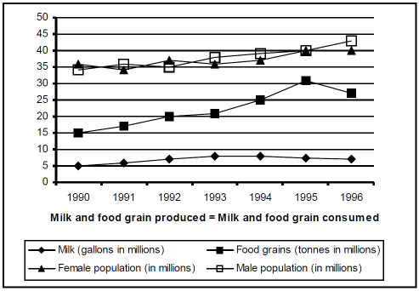

1. When was the per capita production of milk least?

a. 1990 b. 1992 c. 1994 d. 1996

2. When was the per capita production of food grains most?

a. 1992 b. 1993 c. 1994 d. 1995

3. In which year was the difference between the percentage increase in the production of food grains and milk maximum?

a. 1993 b. 1994 c. 1995 d. 1996

4. If milk contains 320 calories and food grains contain 160 calories, in which year was the per capita consumption of calories highest?

a. 1993 b. 1994 c. 1995 d. 1996

5. If one gallon milk contains 120 g of a particular nutrient and one tonne of food grains contains 80 g of the same nutrient, in which year was the availability of this nutrient maximum?

a. 1993 b. 1994 c. 1995 d. 1996

6. Referring to the above question, in which year was the per capita consumption of this nutrient highest?

a. 1993 b. 1994 c. 1995 d. 1996

**Directions (Q. Nos. 7 – 10):** *Answer the questions based on the following information.*

The following chart shows share price movements of select shares over 5 months (first Friday of each month) at the Bombay Stock exchange. The share price movements are given for five companies, namely Infosys, TCS, Maruti, BPCL and IOCL.

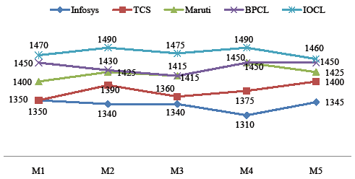

7. Your trading strategy involves buying a stock one month and selling it the next month and you engage in only one transaction (buy and sell). Which transaction will give you the maximum percentage return?

a. TCS : Buy in M1

b. Infosys : Buy in M1

c. IOCL : Buy in M1

d. Infosys : Buy in M4

8. If your trading strategy involves selling a stock in a month day and buying it at a lower price the next month, and you are limited to one such transaction. Which of the following transactions would you be involved in to earn the maximum percentage return? [Percentage return = × 100]

a. Sell IOCL in M4

b. Sell Maruti in M4

c. Sell TCS in M2

d. Sell Infosys in M3

9. If your trading strategy is to buy one stock in M1 and sell it in M5, which stock would you buy to get the maximum percentage return on investment?

a. Maruti b. TCS c. BPCL d. Infosys

10. What is the average price per share in M4 for the given five shares?

a. 1416 b. 1421.5 c. 1425 d. 1415

**Directions (Q. Nos. 11 – 15):** *Answer the questions based on the following information.*

The line charts given below give the expenditure and income of Maruti which produces and sells only two variants of its car - Wagon R and Alto K10.

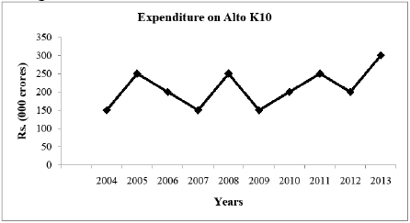

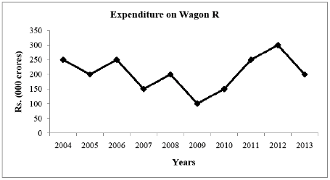

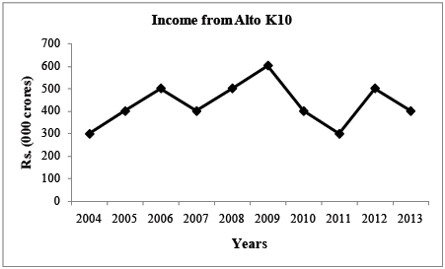

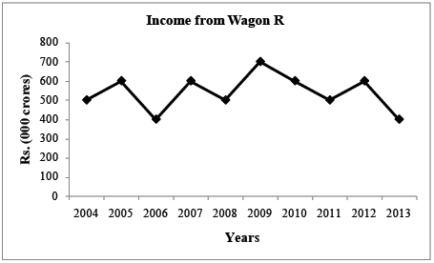

Profit = Income − Expenditure

11. In which years the profit of Maruti the highest?

a. 2007 b. 2009

c. 2012 d. None of these

12. In which year the total profit of Maruti saw the highest percentage increase?

a. 2007 b. 2012

c. 2010 d. 2008

13. In which of the following years was the percentage increase in the income of Alto K10 over the previous year, the highest?

a. 2005 b. 2007 c. 2009 d. 2012

14. For how many years during from 2005 to 2013, was there a growth in income compared to that of the previous year but there is a decrease in expenditure of Wagon R?

a. 1 b. 2 c. 3 d. 4

15. In which of the following years during 2005 to 2013, did the profit of Wagon R decrease by the maximum amount when compared to that of the previous year?

a. 201 b. 2006 c. 2012 d. 2008

**Directions (Q. Nos. 16 – 19):** *Answer the questions based on the following information.*

The following line graphs give the land area under coffee cultivation and tea cultivation and the respective production for 2008 to 2013.

Yield is defined in terms of tonnes per square kilometre.

Land utilization is defined in terms of square kilometre per million tonne.

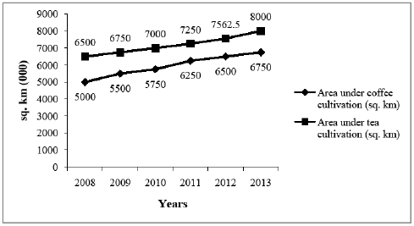

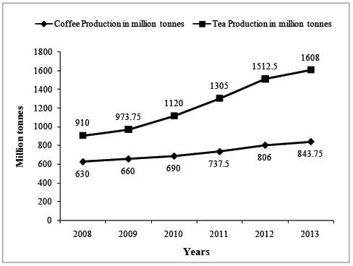

16. Increase in yield compared to the previous year for tea is the lowest for which of the following years?

a. 2010 b. 2009 c. 2012 d. 2013

17. Collective land utilization (total area of cultivation per unit of total production) is the highest in:

a. 2009 b. 2011

c. 2013 d. None of these

18. In 2010, what area under coffee should be put under tea in order to have the same yield for tea and coffee as the collective average yield for 2010? (Assume the total production for both tea and coffee to remain the same as given.)

a. 889480 b. 895650 c. 916187 d. 920501

19. If the land area for coffee increase by 5% in 2013-14 and production of coffee increases to 1095 million tonnes, then the yield for 2014 will be:

a. 158.36 b. 159.49

c. 162.01 d. None of these

Practice Exercise – Difficult

**Directions (Q. Nos. 1 – 5):** *Answer the questions based on the following information.*

Ghosh Babu has a manufacturing unit. The following graph gives the cost for various number of units.

Given: Profit = Revenue – Variable cost – Fixed cost. The fixed cost remains constant up to 34 units after

which additional investment is to be done in fixed assets. In any case, production cannot exceed 50 units.

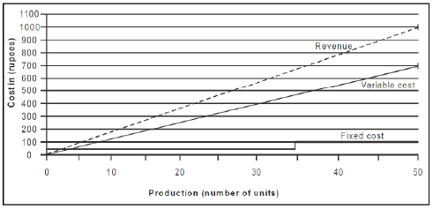

1. What is the minimum number of units that need to be produced to make sure that there was no loss?

a. 5 b. 10

c. 20 d. Indeterminable

2. How many units should be manufactured such that the profit was at least Rs. 50?

a. 20 b. 34 c. 45 d. 30

3. If at the most 40 units can be manufactured, then what is the number of units that can be manufactured to maximise profit per unit?

a. 40 b. 34 c. 35 d. 25

4. If the production cannot exceed 45 units, then what is the number of units that can maximise profit per unit?

a. 40 b. 34 c. 45 d. 35

5. If the fixed cost of production goes up by Rs. 40, then what is the minimum number of units that need to be manufactured to make sure that there is no loss?

a. 10 b. 19 c. 15 d. 20

**Directions (Q. Nos. 6 – 9):** *Answer the questions based on the following information.*

International Cricket Commission recently organised a cricket tournament in which four teams participated. The teams were India, South Africa, Pakistan and West Indies. In the tournament, all the matches were scheduled to take place on four different venues, namely Adelaide, Hobart, Hamilton and Perth. Below is a chart of the matches won by these teams at different venues at a certain stage of the tournament, as captured by an observer.

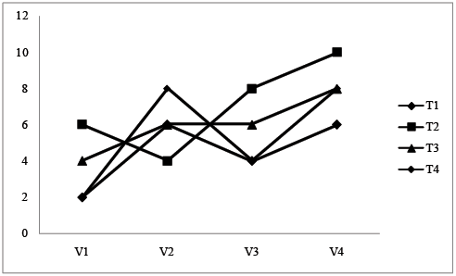

The observer being absent minded did not bring the participating countries' names and venues of the tournament along with the data. However, it is known that the teams must have been listed from top to bottom row wise at the left side of the table while each column must have represented a unique venue. Further information that the observer could retain is:

I. At Hobart, maximum matches were won by West Indies.

II. Pakistan won its minimum matches at Adelaide.

III. South Africa has won 2 matches less than Pakistan.

6. Which two countries could have won equal number of matches at Hobart?

a. Pakistan & India b. South Africa & Pakistan

c. India & West Indies d. None of these

7. Which of the following can never be correct?

I. India won the highest number of matches in Adelaide.

II. At Perth the team with highest number of victories was Pakistan.

III. South Africa won the least number of matches in total.

a. Only I b. I and II

c. II and III d. All are incorrect

8. Which of the following is correct?

I. India won least number of matches at all the grounds.

II. India has won the least number of matches.

III. West Indies have won most number of matches at Hobart among its victories.

a. Only II b. I and II

c. II and III d. Only III

9. In Perth, no country has won lesser matches than South Africa. Which of the following may be correct?

I. West Indies won its least number of matches in Hamilton.

II. South Africa won its least number of matches in Perth.

III. In Hamilton, India has won the maximum number matches among team.

a. Only I b. I and II

c. II and III d. All are correct

**Directions (Q. Nos. 10 – 12):** *Answer the questions based on the following information.*

The following line charts gives the data about Team Englands disasterous performance over past 4 years. Teams overall performance is calculated as half the sum of its four components − Bowling Overall, Bowling Death Overs, Batting Overall and Batting Death Overs.

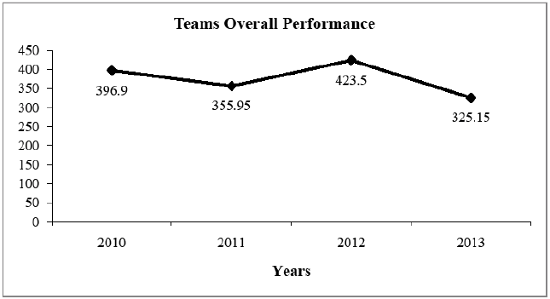

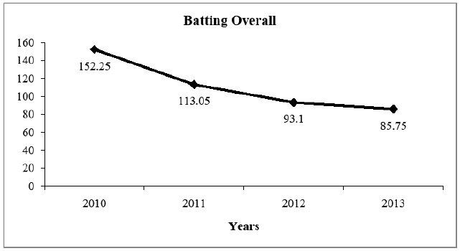

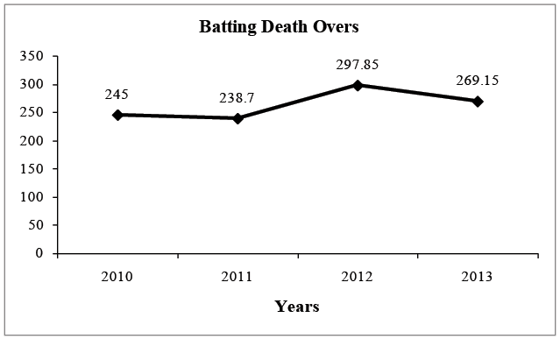

10. In 2013, Bowling Overall is down to 105.7 from 133 in 2012, what is Bowling Death Overs percentage change in May 2013?

a. 58.3% b. 36.18%

c. 41.27% d. None of these

11. Bowling in death overs has a score of 135.25 in 2013 and has increased by 10% every year since 2010, then which component suffered greatest decrease from 2012 to 2013?

a. Batting overall b. Batting death overs

c. Bowling death overs d. Bowler overall

12. The percentage decrease of Batting Overall from May 2010 to 2012 and 2011 to 2013 are in the ratio (approx.)?

a. 43:17 b. 39:24 c. 41:28 d. 47:31

**Directions (Q. Nos. 13 – 15):** *Answer the questions based on the following information.*

The graph below gives the installed capacity of two brands, Surf and Wheel, as a percentage of utilized capacity for the 5 years period Y1 to Y5. The installed capacity of Surf is 50 lakh kilograms units and that of Wheel is 80000 kilograms across the given period.

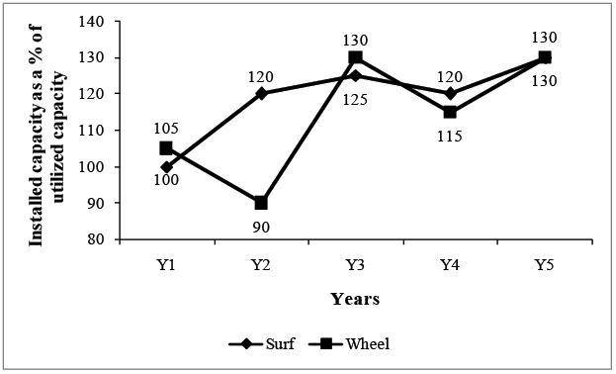

13. What is the average production of Surf?

a. 59.5 b. 55.75

c. 58.75 d. None of these

14. In which year was the difference in the production of Wheel and Surf maximum?

a. Y3 b. Y2

c. Y4 d. None of these

15. In which year the ratio of wheel to Surf the lowest?

a. Y3 b. Y4

c. Y5 d. None of these

**Directions (Q. Nos. 16 – 21):** *Answer the questions based on the following information.*

ABC Ltd. produces widgets for which the demand is unlimited and they can sell all of their production. The graph below describes the monthly variable costs incurred by the company as a function of the quantity produced. In addition, operating the plant for the first shift results in a fixed monthly cost of Rs. 800. Fixed monthly costs for second shift operation is estimated at Rs. 1,200. Each shift operation provides capacity for producing 30 widgets per month.

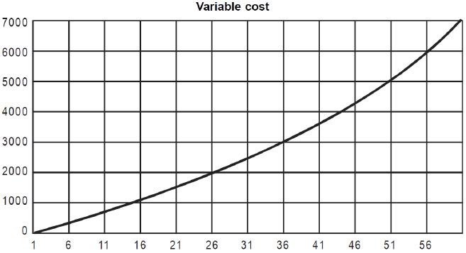

**Note:** Average unit cost, AC = Total monthly costs/Monthly production and marginal cost, MC is the rate of change in total cost for unit change in quantity produced. **[CAT 2000]**

16. Total production in July is 40 units. What is the approximate average unit cost for July?

a. 3,600 b. 90 c. 140 d. 115

17. ABC Ltd. is considering increasing the production level. What is the approximate marginal cost of increasing production from its July level of 40 units?

a. 110 b. 130 c. 150 d. 160

18. From the data provided it can be inferred that, for production levels in the range of 0 to 60 units,

a. MC is an increasing function of production quantity

b. MC is a decreasing function of production quantity

c. initially MC is a decreasing function of production quantity, attains a minimum and then it is an increasing function of production quantity

d. None of the above

19. Suppose that each widget sells for Rs. 150. What is the profit earned by ABC Ltd. in July?

(Profit is defined as the excess of sales revenue over total cost.)

a. 2,400 b. 1,600 c. 400 d. 0

20. Assume that the unit price is Rs. 150 and profit is defined as the excess of sales revenue over total costs. What is the monthly production level of ABC Ltd. at which the profit is highest?

a. 30 b. 50 c. 60 d. 40

21. For monthly production level in the range of 0 to 30 units,

a. AC is always higher than MC

b. AC is always lower than MC

c. AC is lower than MC up to a certain level and then is higher than MC.

d. None of the above